The following instructions have been written following the required format (line spacing, margins, fonts, titles, etc.). Use them as a TEMPLATE for your communication. Keep in mind that the revision process will also consider format as an acceptance criterion and therefore, your communication can be rejected if it is not written according to these instructions.

DO NOT INCLUDE THE TITLE

DO NOT INCLUDE THE AUTHORS OR CONTACT INFORMATION

DO NOT INCLUDE ABSTRACT, KEYWORKDS OR ACKNOWLEDGEMENTS

# Introduction

Your communication has been accepted for publication in the Proceedings of the International Congress on Project Management and Engineering. All papers accepted after the review process performed by the Scientific Committee of the Congress, will be published in electronic format. This requires the submission of the communication in electronic form, both in Word and Pdf format via the online platform developed for the Congress. Regarding the publication of the Book of Abstracts, there will be no distinction between communications which are finally exposed orally and those presented by poster. The length of all communications will vary between 8 and 12 pages (without considering the references).

In order to edit the Book of Abstracts of the Congress with uniform format and style, we kindly ask you to collaborate by following the instructions set out in this guide. These instructions also serve as an example, as they follow the same format. Take notice that reviewers can reject any communication not using this format.

Papers will consist of six parts: Title, Abstract (summary in English), Resumen (summary in Spanish), Correspondence (contact details), Content and References. You only have to submit Content and References, because the other parts will be completed with the information you introduced in the platform. If needed, you may include Acknowledgements via the online platform, just after Correspondence.

The content of the communication is the main part of the article, and can be divided into several sections. We recommend the following: introduction, objectives, methodology and/or case study, results and conclusions.

# Paper Layout

Please prepare your paper in A4 paper size (width 21.0 cm and height 29.7 cm), with single column format. Set the margins as specified in table 1, which offers an area of 160 mm x 237 mm available for text.

Table 1: Page margins

|  |  |
| --- | --- |
| Margin | Measure (mm) |
| Top | 30 |
| Bottom | 30 |
| Left | 25 |
| Right | 25 |
| Header | 10 |
| Footer | 10 |

## Styles

The text main body should use Arial font 11 pt, justified, single spaced and spacing before 6 pt. It is style “Main text” of this template, as seen in Figure 1.

Figure 1: Main text’s style

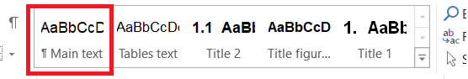

## Headings

The first level of headings (numbered) will use Arial font 12 pt bold, aligned to the left, single spaced and spacing 18 pt before and 6 pt after, as a sentence. Put the important words in uppercases.

The second level of headings (numbered) will use Arial font 11 pt bold, aligned to the left, single spaced and previous spacing of 12 pt, as a sentence. Put the important words in uppercases.

Regarding the “Line and Page Breaks” options, the style of the paragraph will be "Don’t hyphenate" and "Keep with next".

The styles of the headings correspond to the styles "Heading 1" (for the first level of headings) and "Heading 2" (for the second level of headings), as marked in Figure 2.

Figure 2: Headings’ style

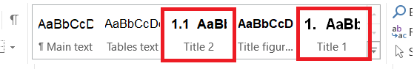

## Figures and Tables

Both figures and tables will be numbered as Figure 1, Figure 2, etc. Table 1, Table 2, etc.

The figures in the paper will be centered on the page, with previous spacing of 18 pt. The caption of the figures will use Arial font 10 pt, bold, centered, single spaced and spacing before 12 pt and 6 pt after. This style is stored under the name "Title figures/tables", as highlighted in Figure 3.

Figure 3: Title figures/tables’ style

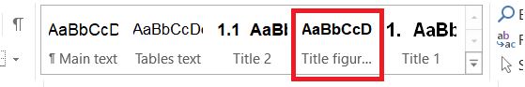

An example figure is shown in Figure 4 below.

Figure 4: Example of figure

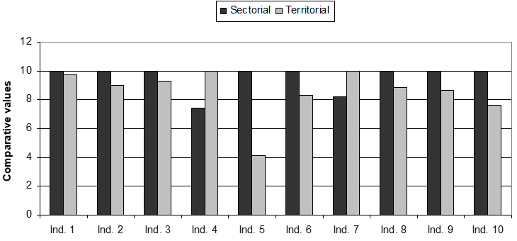

Note: in case any clarification is needed, it shall be written here.

It is highly recommended to create images and figures in color, in order to improve the clarity and quality of the paper. The text will refer to the figure by its number; for example: as shown in Figure 3 (never write “in the figure above” or “the figure of page 7”).

Tables should be centered; the text of the tables use Arial font 10 pt, centered, and with previous and subsequent spacing of 3pt (it is also predefined by default in the style ribbon, see Figure 5). The legends of the tables is the same as that of the figures (Arial font 10 pt, bold, centered, single spaced and with spacing before 12 pt and 6 pt after, see Figure 3). Below is an example of a table with its title.

Figure 5: Text tables’ style

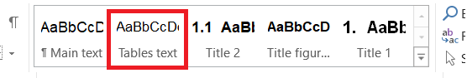

Table 2: Distribution of Authors by Continent for the Period 2000-2005

|  |  |  |  |  |  |
| --- | --- | --- | --- | --- | --- |
|  | First autor  (*n* = 1,582) | |  | All authors  (*n* = 3,401) | |
|  | Nº. | % |  | No. | % |
| North America | 1,240 | 78.4 |  | 2,702 | 79.4 |
| Europe | 217 | 13.7 |  | 425 | 12.5 |
| Oceania | 48 | 3.0 |  | 114 | 3.4 |
| Asia | 48 | 3.0 |  | 81 | 2.4 |
| Africa | 27 | 1.7 |  | 70 | 2.1 |
| South America | 2 | 0.1 |  | 9 | 0.3 |

## Lists

* Lists without numbering should preferably use a bullet point, and will use Arial font 11 pt, justified, spaced previous 6 pt, 0.63 cm indentation, with 0.63 cm in tabulation. Lists without numbering can alternatively use a hyphen (-) as a bullet.

1. Numbered lists should be Arial 11 pt, justified, spaced previous 6 pt, 0.63 cm indentation, with 0.63 cm in tabulation.

## Equations

The equations will be centered with previous spacing 12 pt. Each equation will be numbered consecutively throughout the article using the decimal numerals within parentheses: (1), (2), etc. The numbering of the equation will be aligned to the right. We recommend using the IS (International System) units.

|  |  |  |
| --- | --- | --- |
|  | $$U=I·R$$ | (1) |

## References

References will follow the APA format. The references will appear alphabetically by the first author's last name; and references of the same author must be arranged in chronological order. In the text, these references have to be cited in parentheses with the surname of the author (s) and the date of publication followed by a comma (e.g.: Angell, 1999).

[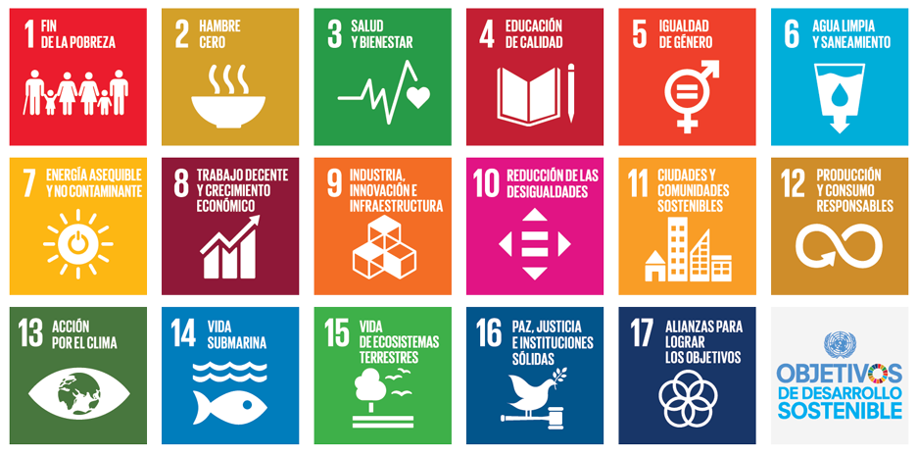](https://www.un.org/sustainabledevelopment/es/objetivos-de-desarrollo-sostenible/)Communication aligned with the Sustainable Development Goals

From this edition on, authors are required to include this section after the references of their communication. A minimum of 1 and a maximum of 2 Sustainable Development Objectives must be included to which the communication contributes or with which it is better aligned.

Please, copy the icon(s) corresponding with the selected Objective(s) and paste it (them) with the size indicated in the template. You can find the icons and a more detailed description of each objective in the following link: [Sustainable Development Goals](https://www.un.org/sustainabledevelopment/).